## **Arm Attachment**

In order to attach all the equipment that is used to extract, process, and transmit data to the simulation, a series of attachments had to be designed to allow the equipment to be carried. These had to be designed to accommodate the equipment that was to be worn on the arm in as little space as possible to allow all the required parts to be worn. This section focuses on describing the design process of each attachment and the connectors used to connect various parts of the network together.

### **IMU Attachment**

To make it easy to swap out the internal measurement units, a decision was made to use mini breadboards to attach each IMU to instead of using a printed circuit board. The mini breadboards contain 55 holes, with 11 columns and 5 rows, making them sufficiently large to be able to fit the MPU9250 Internal measurement unit on, and at the same time small enough to fit onto the arm. To allow the system to sense motion of the entire arm, one IMU is attached to the upper arm, one to the forearm and the last one to the hand.

To attach the mini breadboard to the arm, dimensions of the mini breadboard were measured, and a platform was designed in fusion 360 for the breadboard to be slotted into with a velcro fastening strip running across the inside of the platform to allow the platform to be fastened to parts of the body. The velcro fastening strip was chosen because it allows for adjustments which allows users with different arm dimensions to wear the equipment. Figure 1 depicts the completed IMU attachment (see appendix A for individual components).

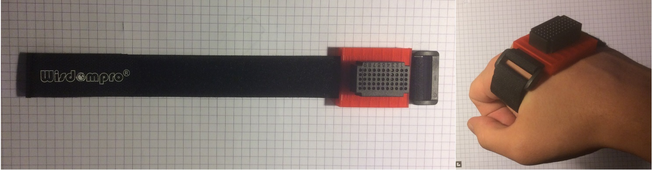

Figure 1: Images depicting the completed IMU attachment.

### **FPGA-STM32L432-Bluetooth Attachment**

To attach all of these components onto the arm, one large attachment was designed to accommodate all the components in a compact manner. Apart from the main three components, also two LIPO 650mAh batteries were attached to provide power to the system, and the forearm IMU was also attached to the platform in order to reduce the number of attachments that have to be fitted onto the arm.

Before the design of the attachment platform, the dimensions of each component were measured (see Appendix B) to provide an estimate of how large the attachment needs to be platform needs to be. Breadboards were used once again attach the STM32L432, Bluetooth module and the forearm internal measurement unit. To accommodate all three components, two 170-hole breadboards were used. The platform was designed such that the FPGA could be screwed in place as it could not be placed onto a breadboard. A dip in the platform was designed to allow the batteries to be attached with velcro underneath the FPGA to allow the to be easily detached if needed. The platform was elongated to allow the two breadboards to be fitted onto each side and a hole on each side was made for the velcro fastening strips. Two fastening strips were needed to minimise movement of the platform and make sure the platform was attached securely due to the length of the attachment.

Machine generated alternative text:



Figure 2: Image depicting the design of the FPGA-STM32L432-Bluetooth attachment in Fusion 360.

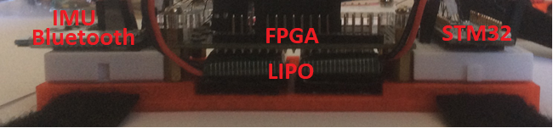

Figure 3: Image depicting the attachment platform with hardware attached.

Due to limited space and the necessity of space for the FPGA programming cable, the space of the left breadboard has been planned and each piece of hardware has dedicated space on the breadboard. The FPGA breadboard can only be programmed using a right-angle mini USB cable when every component is placed on the breadboard and connected. Figure 4 depicts the layout of the of each component on the breadboard.

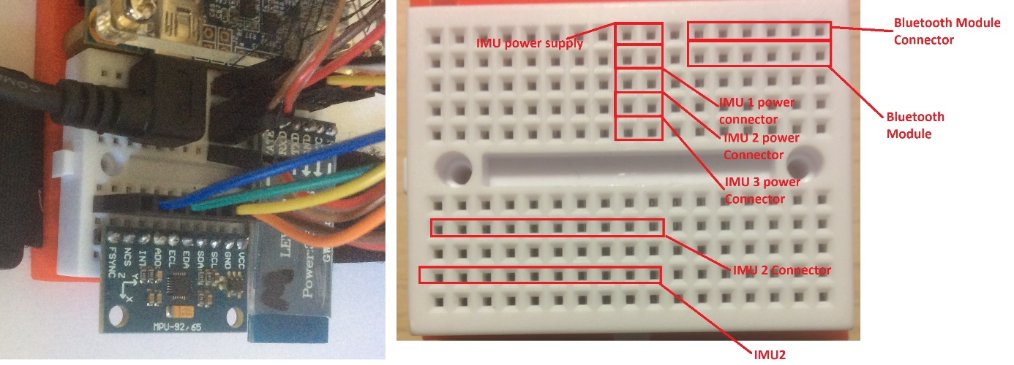

Figure 4: Image depicting the component layout (Left) and the component and connector layout plan (Right).

The FPGA, LiPo batteries and the STM32L432 were arranged such that the battery cables can be connected to the power pins of the two boards. This had to be done as the battery cables are short. These batteries were chosen as they provide a voltage of 3.7 volts which is enough to power the DE0 Nano FPGA board and the STM32L432 board without requiring any additional circuitry as would be the case with a common 9-volt battery which would require a buck converter to step down the voltage to 5 volts for the FPGA and approximately 7 volts for the STM32L432 board.

# **Appendix A**

Components used to create the IMU attachment.

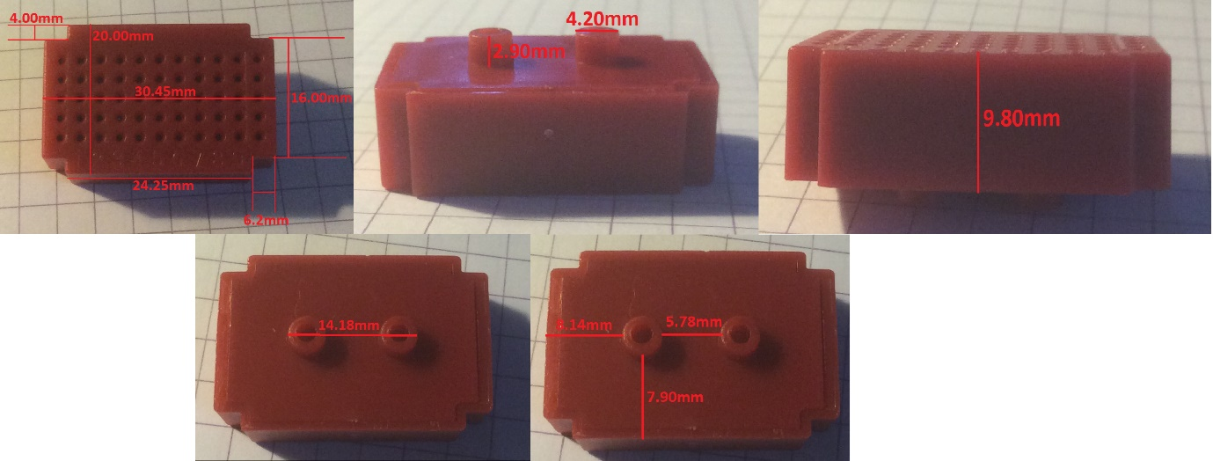

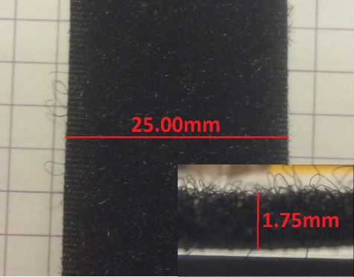

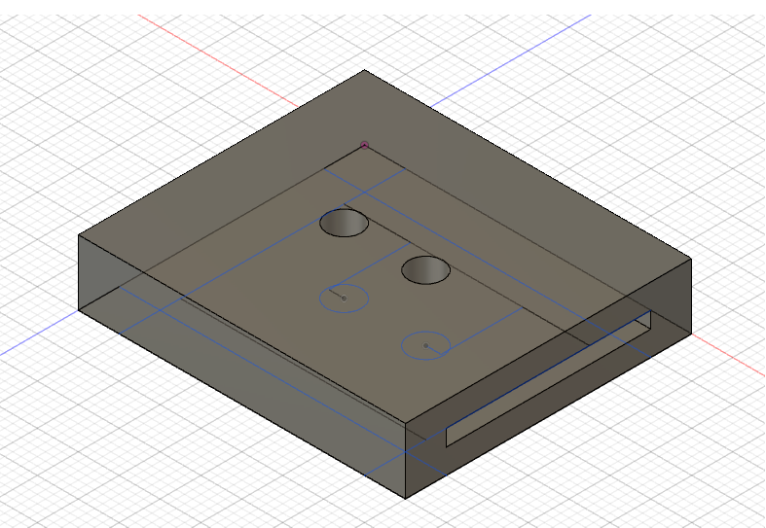

# **Appendix B**

Component measurements for the FPGA-STMEL432-Bluetooth attachment

